# Accessibility Guide for Crow's Nest, 6 Spanish Ledge

[hello@Scillyholidayhomes.co.uk](mailto:hello@Scillyholidayhomes.co.uk) / 01720 421305

**Contact for accessibility enquiries: Laurie Wilson**

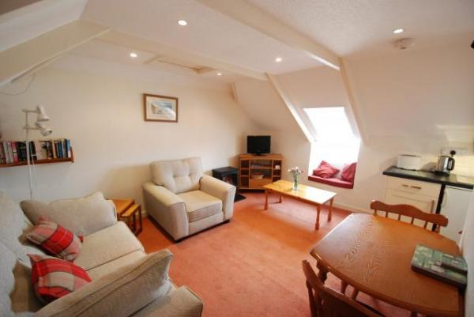

### Welcome

The Crow's Nest is a centrally located second floor apartment for two people. It comprises kitchen, lounge, shower room and twin bedroom and is located just off Porthcressa beach on Silver Street.

## At a Glance

### Level Access

* The main entrance has 2 steps and a handrail. There is no lift and no ramp.
* There is level access from the main entrance to: n/a.

### Bedrooms

* We have non-allergic bedding.

### Level access bedrooms

* From the main entrance to the bedroom, there is level access.

### Hearing

* The (bedroom) TVs have subtitles.

### Getting here

6 Spanish Ledge,  
Silver St, St Mary's, TR21 0LP

#### Travel by public transport

* Sail from Penzance on the Scillonian Ferry - Isles of Scilly Steamship Group; 01736 334220, [www.islesofscilly-travel.co.uk](http://www.islesofscilly-travel.co.uk)
* Fly Skybus from Land's End, Newquay or Exeter Airports - Isles of Scilly Steamship Group; 01736 334220, [www.islesofscilly-travel.co.uk](http://www.islesofscilly-travel.co.uk)
* Fly via helicopter from Penzance to St Mary’s or Tresco – Penzance Helicopters; 01736780828 [www.penzancehelicopters.co.uk](http://www.penzancehelicopters.co.uk)
* National and European connections available from Newquay and Exeter.

#### Travel by taxi

* You can get a taxi with Buzza Bus by calling 01872 266886. The taxi company has a wheelchair accessible vehicle.
* You can get a taxi with Toots Taxi by calling 01720 422142.
* You can get a taxi with DJ Cabs by calling 01720 423775.
* Each Skybus & Helicopter flight is met by a Islands Transfers; www.islandtransfers.co.uk / 01720 422126 at St Mary's Airport. If arriving by boat, taxis can be booked for quayside collection.

#### Parking

* There is a drop-off point at the main entrance. The drop-off point does not have a dropped kerb.
* The entrance is up a flight of external stairs.

## Arrival

#### Path to main entrance

* From the street to the main entrance, there are 22 steps. There is no ramp and no lift.

#### Main entrance

* The door is 760mm wide.
* The main entrance has 2 steps.
* This entrance has a handrail.
* The main door is side hung and manual.
* If arriving from the airport, your Island Transfers driver will help unload bags from the bus. If arriving by boat, you can arrange for your luggage to be delivered from the quay to the door for a small fee. Please call Island Carriers on 01720 422662 or Richard Hand Haulage on 01720 423007 to arrange.

## Getting around inside

#### Bedrooms

* All bedrooms have windows.
* Bedrooms have ceiling lights and bedside lamps.
* Lights are halogen, LED and energy saving. Some lights can be controlled independently.
* TVs have subtitles.
* All bedrooms are non-smoking.
* We have non-allergic bedding.
* All bedrooms have fitted carpets.
* From the main entrance to this area, there is level access.

#### Self catering kitchen

* We have an open plan kitchen.

#### Lounge

* From the main entrance to the lounge, there is level access.

## Customer care support

#### Accessibility equipment

* Wheelchairs, mobility scooters and electric golf buggies can be hired locally.
* For a list of more items, please contact the Tourist Information Centre; [info@visitislesofscilly.com](mailto:info@visitislesofscilly.com) / 01720 62060 / [www.visitislesofscilly.com](http://www.visitislesofscilly.com)

#### Customer care support

* Scilly Holiday Homes provides an out of hours emergency phone number in all its self-catering properties.

Guide last updated: 05/12/2024